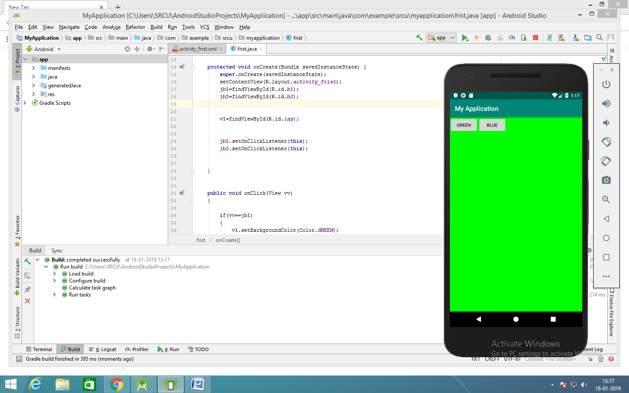

*<?***xml version="1.0" encoding="utf-8"***?>*<**LinearLayout xmlns:android="http://schemas.android.com/apk/res/android"  
 xmlns:app="http://schemas.android.com/apk/res-auto"  
 xmlns:tools="http://schemas.android.com/tools"  
 android:id="@+id/lay"  
 android:layout_width="match_parent"  
 android:layout_height="match_parent"  
 tools:context=".frist"**>  
  
  
 <**Button  
 android:id="@+id/b1"  
 android:layout_width="wrap_content"  
 android:layout_height="wrap_content"  
 android:text="green"**

**Android: onclick=”f1”  
 tools:layout_editor_absoluteX="155dp"  
 tools:layout_editor_absoluteY="229dp"** />  
  
 <**Button  
 android:id="@+id/b2"  
 android:layout_width="wrap_content"  
 android:layout_height="wrap_content"  
 android:text="blue"**

**Android: onclick=”f2”  
 tools:layout_editor_absoluteX="155dp"  
 tools:layout_editor_absoluteY="341dp"** />  
  
  
</**LinearLayout**>

**import** android.graphics.Color;  
**import** android.support.v7.app.AppCompatActivity;  
**import** android.os.Bundle;  
**import** android.view.View;  
**import** android.widget.*;  
  
**public class** frist **extends** AppCompatActivity {  
  
   
 View **v1**;  
  
 **protected void** onCreate(Bundle savedInstanceState) {  
 **super**.onCreate(savedInstanceState);  
 setContentView(R.layout.***activity_frist***);

**jb1**=findViewById(R.id.***b1***);  
 **jb2**=findViewById(R.id.***b2***);  
  
  
 **v1**=findViewById(R.id.***lay***);  
  
  
  
  
 }  
  
  
 **public void** f1(View vv)  
 {  
  
 **v1**.setBackgroundColor(Color.***GREEN***);  
 }

**public void** f2(View vv)  
 {  
  
 **v1**.setBackgroundColor(Color.***GREEN***);  
 }

}  
}